reparation of Papers for the 38th Colloquium Conference Proceedings

First name Last name1a, First name Last Name1, and First name Last Name2

1 Department of Control and Transport Automation, Faculty of Transportation Engineering and Vehicle Engineering,  
Budapest University of Technology and Economics

2 Department of Control, Faculty of Electrical Engineering and Informatics,  
Budapest University of Technology and Economics

a Corresponding author: author1@mail.eu

Abstract

These instructions give you guidelines for preparing papers for 38th Colloquium Conference Proceedings. Use this document as a template to compose your paper if you are using Microsoft Word. Otherwise, use this document as an instruction set. If you already have your manuscript ready, please either copy it over to the template, or copy this template to the end of your manuscript file (this will bring over the styles), and set the style of each paragraph as required. Using pre-defined styles makes the editing of paragraph more convenient and applies all settings at once. Proper style setting will not only show the expected format and length of the paper, but also helps typesetting. Do not use free lines (enters) to insert more space before/after titles or paragraphs. The abstract should be concise and no longer than 1500 characters or 150 words. The abstract should not contain citations.

**Keywords:** keyword1, keyword2, more parts keyword

Introduction

This document is a template for Microsoft Word. Please send your paper in doc or docx format and in PDF format too, to show your original version of document arrangement. Embed all figures and tables into the text. Expected length of manuscripts is 4 pages (min. 3.5 pages).

General editing instructions

Papers must be submitted in English using American spelling. Expressions in other languages should be translated to English everywhere in the text, figures, and tables. Always use dot (.) as decimal separator instead of comma (,).

Styles

Please always use the pre-defined styles of this document for the appropriate section (including: 0_*, *Main title and other Title styles, Abstract, Abstract title, Affiliation, Keywords, Author, Equation, Figure, Figure caption, Table, Table caption, NormalText, Ref.title, References, Footer_even, Footer_odd*). Do not use any other spacing in the text (e.g. enters) – the required spaces are embedded into the styles. Take care that styles do not include font style (bold, italic) and index-format (upper, lower) – these should be set manually after applying the appropriate style for the paragraph.

Title

The main words in the title start with capital letter, articles and conjunctions with lowercase letters. Please also write a shorter running title in the page footer if the main title is long.

Authors and affiliations

Please specify the full author name with non-abbreviated first (Christian) and last (family) names. Affiliations are given in the subsequent paragraphs. Affiliations contain the name of the company or university and the department. E-mail contact should be given only for the corresponding author.

Keywords

Keywords start with lowercase character and are separated by comma. Please give 3-5 keywords or expressions that well describe the topic of your work.

Other editing instructions

All sections are numbered consecutively except for the Acknowledgement and the References. Please do not use automatic hyphenation. Take care to the line breakings – if automatic break happens to separate coherent words (e.g. 32 mm, 5-6 years), use non-breaking space (Ctrl+Shift+Space) or non-breaking hyphen (Ctrl+Shift+”-“).

This is third level title style

We recommend not using more than 3 levels of Titles.

Figures

Figures can be color, but take into account – especially for diagrams – that the Conference Proceedings will be printed in grayscale. Recommended image formats are JPG, GIF, PNG or TIFF. Please do not use BMP files due to their big size – use PNG instead. Please do not create line drawings with the built-in features of Microsoft Word, always embed image files. (If you create a line drawing in Word, make a snapshot of it – for example with Microsoft Snipping Tool – and paste the image file into your manuscript.) We encourage you also to use high resolution snapshot image from outer softwares (e.g. Excel diagrams) instead of embedded active object – it ensures layout fidelity and better result in printed material.

It is essential that the bitmap images have sufﬁcient resolution to allow faithful reproduction. To determine the optimum resolution (width × height) of an image, measure the width and height as it appears in your document (in millimeters), and then multiply those two values by 12. For example, a square image of 80 mm wide, i.e. having the width of a single column, the optimal size is about 1000 × 1000 pixel resolution (300 ppi) and should be at least 600 × 600 (200 ppi). Figures should not have extra white borders and must be properly cropped. An example bitmap image is shown by Fig. 1. Figures are numbered consecutively. Please refer every figure from the text.

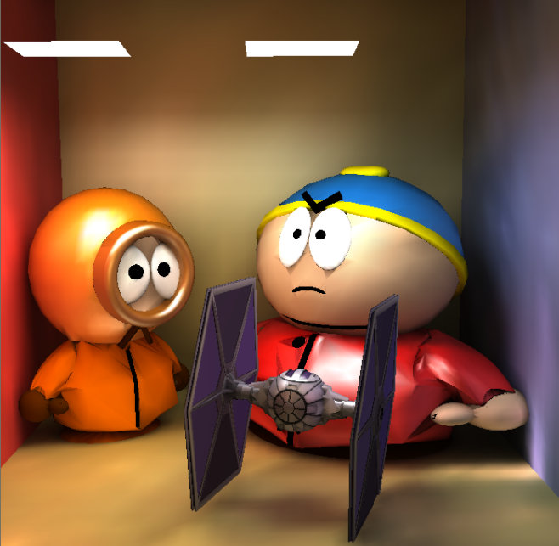

**Figure 1.** Bitmap image of such size should have at least 600 × 600 (200 ppi) resolution. Note that “Fig.” is abbreviated. Please always write an informative caption that explains the significance of the figure

To insert images in Word, position the cursor at the insertion point and use Insert/Picture/From File or simply drag and drop the image into Word, and then, apply *Figure* style to its paragraph. Always insert figures in a free line (as new paragraph) instead of as floating object, and never let text flow around the image. If you would like to present more small images, place them beside each other, use one image caption and refer them as Fig. 2/a, Fig. 2/b etc.

Place of figures

All figures must be embedded in the document when the paper is submitted to review.

 

b)

a)

**Figure 2.** Vector format line drawing in EPS (a) and the same figure as bitmap (b)

Equations

We recommend to use the *equation editor* launched by the Insert/Equation command to create and edit equations. Number equations consecutively with equation numbers in parentheses flushed to the right margin, as in Eq. (1). Apply the *Equation1* style to the paragraph and use tabulator before the equation and between the equation and the numbering. In such way the equation will be center-aligned and the numbering left-aligned. Punctuate equations when they are part of a sentence, as in

$L\left(x,ω\right)=L^{e}\left(x,ω\right)+\int_{Ω}{L\left(y,ω^{'}\right)f_{r}}\left(ω^{'},x,ω\right)\text{d}ω'$. (1)

Refer to equations as “(1)” or as “Eq. (1)”, but not as “equation (1)”, except at the beginning of a sentence, e.g. “Equation (1) is ... ”. Whenever possible, inline mathematics should also be typed with the equation editor, e.g. in Eq. (1) function $f_{r}\left(ω^{'},x,ω\right)$ is called the BRDF.

$E={mc}^{2}$. (2)

Be sure that the symbols in your equation have been defined before the equation appears or define them immediately following. Italicize symbols but not units of measure (variable *T* might refer to temperature, but T is the unit tesla).

Tables

Tables could be created with the Insert/Table command or by inserting as images. Please pay attention to the same format of tables in the whole manuscript. Tables are to be referred as “Table 1”. Tables get consecutive numbers similarly to figures. Please refer every table explicitly in the text. Table captions have to be above the table, using *Table caption* style.

Page margins and footer

All dimensions are in centimeters as shown by *Table 1.* Footer of even pages (2nd and 4th) should contain the first author and the title of the manuscript – please save page numbering color as black and further text as gray.

**Table 1.** Page margins in centimeters

|  |  |  |  |
| --- | --- | --- | --- |
| ***Page*** | ***Top*** | ***Bottom*** | ***Left/Right*** |
| general | 2 | 2.5 | 2.5 |
| odd | 2 | 2.5 | 2.5 |
| even | 2 | 2.5 | 2.5 |

Conclusion

Although a conclusion may review the main points of the paper, do not replicate the abstract as the conclusion. A conclusion might elaborate on the importance of the work or suggest applications and extensions.

Acknowledgement

The project presented in this article is supported by xxx.

References

References should be made to the latest literature and possibly to well-respected scientific journals that are important in the field [1]. Use References style, which also includes numbering format.

1. Bridson, R., Fedkiw, R., & Anderson, J. (2002). Robust treatment of collisions, contact and friction for cloth animation. ACM Transactions on Graphics, 21(3), pp. 594–603, DOI:10.1145/566654.566623.
2. Lee, Y., Terzopoulos, D., & Walters, K. (1995). Realistic modeling for facial animation. Proceedings of the 22nd Annual Conference on Computer Graphics and Interactive Techniques SIGGRAPH 95, 95, pp. 55–62, DOI:10.1145/218380.218407.
3. Muyan-Özçelik, P., Glavtchev, V., Ota, J. M., & Owens, J. D. (2011). Real-time speed-limit-sign recognition on an embedded system using a GPU. In GPU Computing Gems Emerald Edition pp. 497–515, DOI:10.1016/B978-0-12-384988-5.00032-2.
4. O’Brien, S. J., & Johnson, W. E. (2005). Big cat genomics. Annual Review of Genomics and Human Genetics, 6, pp. 407–429, DOI:10.1146/annurev.genom.6.080604.162151.
5. Silvio, T. (2010). Animation: The New Performance. Journal of Linguistic Anthropology, 20(2), pp. 422‑438, DOI:10.1111/j.1548-1395.2010.01078.x.